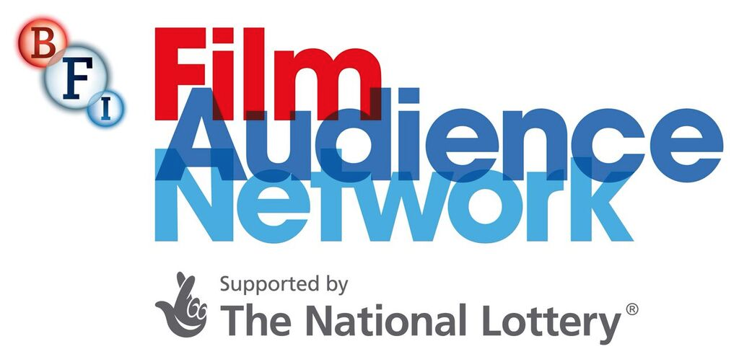

Being LGBTQ+ Friendly
Top tips & terminology

- Work with LGBTQ+ people themselves, whether it’s working with community or national organisations or with people within your own organisation.
- Employ a more diverse workforce at all levels. Welcome diverse groups in your job applications and your mission statements.
- If you can, get training delivered to staff about how to engage sensitively with audiences, and for a better understanding of the experience of LGBTQ+ people.
- Consider that people have multiple identities so communication needs to work for LGBTQ+ people across your whole programme, and don’t presume that you will only have an LGBTQ+ turnout for your targeted programming.
- Get LGBTQ+ people to audit your venue to give feedback about how the space feels, about signage, and about the customer service experience.
- Make sure you take feedback on board and actually use it, and share your reasoning across the organisation.
- Consider the tone of your signage - can you be gender neutral?
- Think about lesser told stories - not just the obvious films… Are you including lesbian and trans stories? Think about the filmmakers and if they have credibility.
- Get LGBTQ+ people to programme and give insights into marketing and audience development. (Best practice with any consultancy is to pay people!)
- Revise your communications with LGBTQ+ insights - what kind of language do you use? Are you welcoming? Is there subtle prejudice in the way you communicate that needs to be considered?
- You’ll need to do more community and social marketing. Engage with charities and relevant LGBTQ+ organisations.
- Use gay bars and clubs/venues and LGBTQ+ centres for your print advertising. If there are Pride events in your calendar, go along…
- Consider your survey. Do you have all the necessary fields for gender and sexuality? It’s a lot better to ask people to self-identify rather than to designate fields around gender.
- Could you be gathering deeper, qualitative, useful feedback - can you make yourself available to audiences for interviews/conversations afterwards?
- Think about opening up a dialogue and your audience will recognise the efforts you are making, and champion you to their networks. Even social media polls can be useful.
- Make it known that you’re trying to improve and willing to listen and learn.

Terminology Glossary

Asexual (or ace) - someone who does not experience sexual attraction.
Bi / bisexual - a romantic or sexual orientation towards more than one gender.
Cisgender or Cis – someone whose gender identity is the same as the sex they were assigned at birth.
Gay – refers to a man who has a romantic or sexual orientation towards men. Some women also define themselves as gay rather than lesbian.
Gender identity - a person’s innate sense of their own gender, whether male, female or something else (see non-binary below), which may or may not correspond to the sex assigned to them at birth.
Gender reassignment – to undergo gender reassignment usually means to undergo some sort of medical intervention, but it can also mean changing names, pronouns, dressing differently and living in your self-identified gender.
Heterosexual / straight - a romantic and/or sexual orientation towards people of the opposite gender.
Intersex – a term used to describe a person who may have the biological attributes of both sexes or whose biological attributes do not fit with societal assumptions about what constitutes male or female.
Lesbian – refers to a woman who has a romantic or sexual orientation towards women.
Non-binary – an umbrella term for a person who does not identify as only male or only female, or who may identify as both.
Pronoun – words we use to refer to people’s gender in conversation - for example, ‘he’ or ‘she’. Some people may prefer others to refer to them in gender neutral language and use pronouns such as they / their. If you’re not sure what pronoun someone prefers, just ask them.
Queer – in the past a derogatory term for LGBT individuals. The term has now been reclaimed by some LGBT people in particular who don’t identify with traditional categories around gender identity and sexual orientation but is still viewed to be derogatory by some. Queer is often used in a film and arts context or to refer to a more intersectional approach.
Trans – an umbrella term to describe people whose gender is not the same as, or does not sit comfortably with, the sex they were assigned at birth. Trans people may describe themselves using one or more of a wide variety of terms, including Transgender, Transsexual, Genderqueer, Genderfluid, Non-binary, Agender, or Two-spirit.
Transgender man – a term used to describe someone who is assigned female at birth but identifies and lives as a man. This may be shortened to trans man or FTM (female-to-male).
Transgender woman – a term used to describe someone who is assigned male at birth but identifies and lives as a woman. This may be shortened to trans woman or MTF (male-to-female).
Transsexual – this was used in the past as a more medical term to refer to someone who transitioned to live in the ‘opposite’ gender to the one assigned at birth. This term is still used by some although most people prefer the term trans or transgender.

