System Crasher
Marketing Pack for venues, part of BFI FAN’s support for new releases
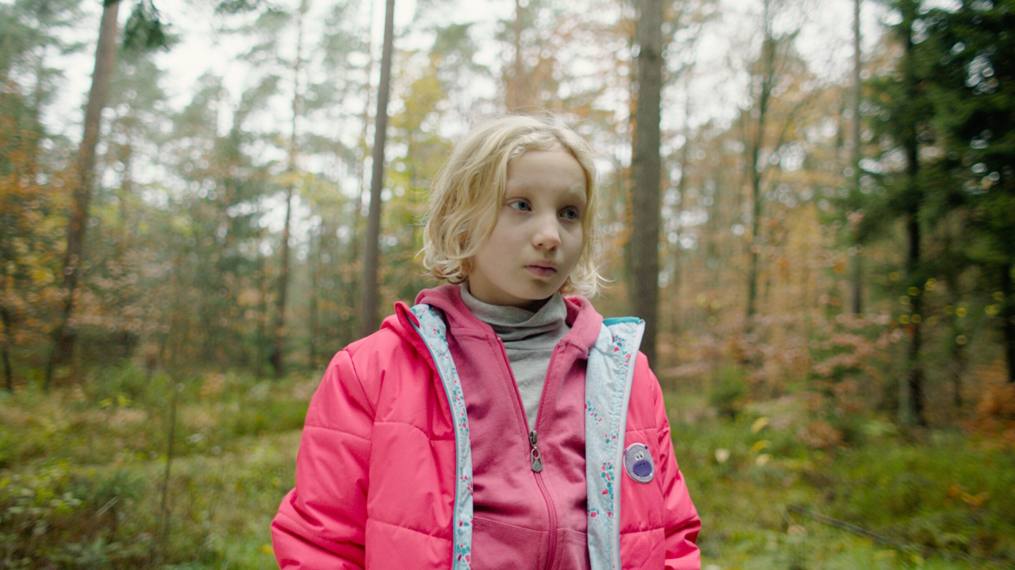
Specification details:
System Crasher
Dir. Nora Fingscheidt | Cert 15 (TBC) |
118 mins | Germany | 2019

Distributor: 606 Distribution
Available: 27 March 2020

Booking: Please email pat.kelman@606distribution.co.uk or james@koenigpictures.com

Non-theatrical bookings will be at a later date (TBC)

Synopsis:
On her wild quest for love, 9-year-old Benni’s untamed energy drives everyone around her to despair.

She is small, but dangerous. Wherever Benni ends up, she is immediately expelled.
The wild 9-year-old girl has already become what child protection services call a “system crasher”. Profoundly affected by childhood trauma, Benni is by turns bright, funny and charming, but can flip at any moment into terrifying violent outbursts.

Mrs. Bafané from child protection services is trying her best to find a permanent placement for Benni, to little success. She hires the anger management trainer Micha as Benni’s school escort and suddenly there is a seed of hope.

Will Micha be able to succeed where all others despaired?

Based on five years of first-hand research, first-time director Nora Fingscheidt has created vibrant, visceral and emotional cinema, full of unforgettable performances. Honest, truthful and extraordinarily powerful, System Crasher is as raw as a Ken Loach film and as exhilarating as Run Lola Run.

Breakout star Helena Zengel was 9 years old at the time of filming, and she has just completed filming News of the World with Tom Hanks and Paul Greengrass.

Official Website: https://www.systemcrasher.co.uk/
Official Facebook: https://www.facebook.com/systemcrasheruk/
Distributor Facebook: https://www.facebook.com/606distribution/
Distributor Twitter handle: @606Distribution
Official hashtag: #SystemCrasher

Promotional assets:

- Official UK Press assets
- Editable posters/stills
- Poster/stills
- Social media assets
- Online interviews with cast

Trailer

- YouTube version
- DCP version

Screener available on request. Please contact pat.kelman@606distribution.co.uk

The Association of Child Protection Professionals

The film is supported by The Association of Child Protection Professionals.

Watch an endorsement by the Head Chairwoman of the AoCPP.
For information on possibly getting an industry professional to introduce your screening or do a Q&A, please contact the AoCPP at:

Association of Child Protection Professionals
17 Priory Street,
York,
YO1 6ET

+44 (0)1904 613605
hello@childprotectionprofessionals.org.uk

If running social media advertising, consider using the following key words/phrases to attract diverse audiences that might be interested in the film:
- Child Protection Services
- Mental Health
- European Cinema
- German Cinema
- Female directors
- F-Rated

We expect System Crasher to appeal to:

- Cinephiles
- European cinema fans
- Young audiences
- People interested in mental health
- People interested in female directors/representation

Simple and easy wins for exhibitors

- Facebook and Instagram ads: this is an easy and effective way at reaching target audiences. FAN support can pay for the ad and we can also talk you through campaign set-up to maximise results.
- Local postcard distribution and postering in hangouts - pubs, clubs, SUs, cafes, venues, festivals

Promote your screenings

Find out how to tell new audiences about your events and make them unforgettable with our simple guides:

- A Simple Guide To: DIGITAL MARKETING: Marketing your events online can be as simple or as complex as you want it to be. To get you started, here are some easy steps to promote your event online.
- A Simple Guide To: AUGMENTING FILM SCREENINGS: Putting on a film screening doesn’t have to be about just showing a film. Venues can make their events stand out and attract new audiences by augmenting their screenings with something extra.

System Crasher: campaign and marketing ideas
The focus of BFI FAN’s support for new releases is developing diverse audiences:

- Price: If you have a young person/student ticket offer, why not promote it alongside System Crasher
- Experience: Research into audiences highlights how important the whole experience is. Think about promoting guest speakers or post-film discussions along with your screenings.
- Interaction / social media: Focus on the fact that it is a film all about outsiders, something that will resonate with most audiences.

Inclusive Cinema assets for more accessible screenings:

Inclusive Cinema is a UK-wide project developed by the BFI Film Audience Network (FAN) designed to support screen exhibitors looking to host more accessible screenings.

- Inclusive Cinema released an autism-friendly screenings guide earlier this year, in collaboration with Dimensions and UKCA. Obviously, this focuses specifically on the experiences of those with ASD, but many of the processes to address supporting audiences with additional needs are transferable. They also produced a quick relaxed screenings guide previous to this.

Event Ideas

- Post-film discussion with film-makers/producers
- Post-film discussions with child protective service reps, mental health experts
- German cinema experts
- Female directors (F-rated)
- Celebration of ‘system crashers’ - women who destroy the system!
- Reach out to charities for potential guest speakers and/or special fund-raising screenings

Other possible partners/guest speakers for screenings (TBC):

- Goethe Institute
- Young Minds
- NSPCC
- The Children’s Society
- Royal College of Psychiatrists
- Place2Be
- Heads Together
- Mind
- Action For Children
- Off The Record (SW)
- Trauma Informed Schools

Children’s Mental Health Week will be 3-9 February 2020, with the theme ‘Find your Brave’.

Planning your event

There is a regional marketing freelancer in each Film Hub region working on grassroots outreach, press and marketing, alongside a small budget for activity. They will also be working with students (both foreign and home) and language schools. Get in touch on fannewreleases@watershed.co.uk to be linked in to the campaign in your area - we can help with event ideas, finding speakers and other grassroots marketing.

- Email template for schools/university/youth networks
- Email template for event screenings
- Email template for contacting venues

Press
Get in touch with local press for any special events with the below press release template alongside stills from the film.

Generic press template for local press and listings

AWARDS:

- Winner of Alfred Bauer Prize at the 69th Berlin International Film Festival
  - Selected to compete for the Golden Bear at the festival.
- Selected as the German entry for the Best International Feature Film at the 92nd Academy Awards.
- Received 3 nominations to the 32nd European Film Awards, including Best Film, Best Actress, University Award.
- Helena Zengel - FIPRESCI Prize for Best Actress at the Palm Springs Film Festival

Key Press Quotes

“Guaranteed to capture your heart and rip it to shreds.” - Flip Screen

“Much like its heroine, (System Crasher) is a bright, ferocious bundle of energy.” - Culture Fly
“In the lead role, young Helena Zengel is mightily impressive, showing the natural depth of a born actress as she pours her energy into System Crasher” - The Hollywood Reporter

“Two tenacious lead performances power this uniquely frank yet compassionate examination of angry childhood.” - Flickering Myth

ARTICLES OF INTEREST

FILM INQUIRY: System Crasher - Broken Hearts and Broken Jaws

https://www.filminquiry.com/system-crasher-2019-review/

DEADLINE: Helmer Nora Fingscheidt On The Surprise Impact Of ‘System Crasher’

https://deadline.com/video/nora-fingscheidt-system-crasher-interview-awardline-screening/

SCREEN DAILY: How Nora Fingscheidt’s ‘System Crasher’ became an arthouse hit in Germany

https://www.screendaily.com/features/how-system-crasher-became-an-arthouse-hit-in-germany/5144393.article

THE WRAP: ‘System Crasher': Helena Zengel Says Being Able to Cuss Drew Her to Wild Child Role

https://www.thewrap.com/system-crasher-helena-zengel-cuss-drew-her-to-wild-child-role/

THINGS TO NOTE:

The talent behind System Crasher are on the verge of ‘breaking big’:

- Director Nora Fingscheidt is currently directing Sandra Bullock in a Netflix feature based on the ‘Unforgiven’ series
- Helena Zengel is now working with Tom Hanks and Paul Greengrass in their latest film News of the World.

FILM COPY

Official Synopsis
On her wild quest for love, 9-year-old Benni’s untamed energy drives everyone around her to despair.

She is small, but dangerous. Wherever Benni ends up, she is immediately expelled.
The wild 9-year-old girl has already become what child protection services call a “system crasher”. Profoundly affected by childhood trauma, Benni is by turns bright, funny and charming, but can flip at any moment into terrifying violent outbursts.

Mrs. Bafané from child protection services is trying her best to find a permanent placement for Benni, to little success. She hires the anger management trainer Micha as Benni’s school escort and suddenly there is a seed of hope.

Will Micha be able to succeed where all others despaired?

Based on five years of first-hand research, first-time director Nora Fingscheidt has created vibrant, visceral and emotional cinema, full of unforgettable performances. Honest, truthful and extraordinarily powerful, System Crasher is as raw as a Ken Loach film and as exhilarating as Run Lola Run.

Breakout star Helena Zengel was 9 years old at the time of filming, and she has just completed filming News of the World with Tom Hanks and Paul Greengrass

SAMPLE SOCIAL MEDIA POSTS

Twitter/Instagram:
“Guaranteed to capture your heart and rip it to shreds.” - @flipscreened

Watch the award-winning, hard-hitting drama #SystemCrasher from @606Distribution.

[VENUE]
[DATE]
[LINK]

Winner of Alfred Bauer Prize at the 69th Berlin International Film Festival, #SystemCrasher is “a bright, ferocious bundle of energy”.

Check it out now:

[VENUE]
[DATE]
[LINK]

Special event:
Join us for a post-show discussion on XXXXXX. [DATE and CTA]

Facebook:
“Guaranteed to capture your heart and rip it to shreds.” - Flip Screen

Winner of Alfred Bauer Prize at the 69th Berlin International Film Festival, #SystemCrasher is “guaranteed to capture your heart and rip it to shreds.”

Watch the trailer now and book tickets.
[LINK]

EXAMPLES OF VENUE COPY FROM PREVIOUS SCREENINGS

Leeds Film Festival

Nine-year-old Benni is a “system crasher”, a foster child whose behaviour is so out of control that she cannot be placed with families. Benni is desperate to be back at home with her mother but Bianca is scared of her own daughter. Determined to find a solution, her case worker aided by Micha, a young man who specializes in anger management, finds there is a glimmer of hope that they might succeed where everyone else failed. First-time director Nora Fingscheidt picked up the Alfred Bauer Prize at the Berlinale for this passionate tale of a foster child pushing the system to its limits.

Independent Cinema Office Screening Days

Controversial from the moment it premiered in Competition at this year’s Berlin Film Festival, documentarian Nora Fingshcheidt’s (Without This World) fiction feature debut System Crasher portrays the life of a chaotic young girl.

Wild and troubled, 9-year-old Benni (Helena Zengel) keeps getting expelled from one foster home after another due to her uncontrollable aggression. Too young to be held in treatment programmes and too violent to stay in group homes, she is a ‘system crasher’ – the unofficial, controversial name given to children who slip through the cracks of the German Child Protective Services. But all is not lost, and thanks to a caring child care worker, a seed of hope appears as Benni is given an anger management trainer to escort her to school and help during the days.

Helena Zengel is deeply impressive in her performance as Benni, commanding the attention of the viewer every second of the way, as Fingscheidt – who based her multi award-winning script on considerable research – demonstrates that it may not be the child who is too difficult to handle, but rather the system that is ill-equipped to deal with cases too far outside their tightly defined norms.

Watershed European Cinema Night Screening

The vulnerability of childhood is laid bare in Nora Fingscheidt’s award winning System Crasher, a wrenching tale of a foster child pushing Germany’s child and welfare system to its limits.

Nine-year-old Benni is a system crasher: a foster kid whose behaviour is so out of control that she cannot be placed with families. Given over to social services by her hapless, abused mother, she is a whirling handful of a child, intelligent and verbose one second, screaming and violent the next. When social worker Micha takes Benni to stay at a cottage in the woods, she discovers glimmers of a childhood she never experienced. But the idyll can only last so long and her return to civilisation will challenge the kindness of all those trying to save her.

A powerful story of a young girl who has lost her place in society, this is a no-holds-barred, deeply humane glimpse into the fraught and at times impossible world of child protection services. Driven by a powerhouse performance from Helena Zengel as the young Benni, System Crasher will leave you reeling.

Bath Film Festival

To say Benni is angry is like saying the Niagara Falls are quite wet. She is a raging torrent of pain, fury, and terror, expressed in a volcanic scream of incandescent hatred of the world. Benni is a nine-year-old girl, who is beyond even the skill and experience of the German social care system – which is why she is a system crasher. Nothing and no one can withstand her – until one person may be able to see a way through. Nora Fingscheidt’s film is a compassionate view of a child’s trauma, but it is the extraordinary performance of Helena Zengel as Benni that brings the film to such a high level of excellence.

London Film Festival

An intense drama about a pre-pubescent girl who actually crashes Germany’s child and welfare system whilst on her quest for love and security.

When neon pink flashing images flood the screen, it’s a sign that nine-year-old Benni has lost all control. She screams, swears, hits out and spits. Though she can be extremely violent, the traumatised girl is also lovable, understanding, vulnerable and very smart. Tossed from one foster home to the next, she dreams of nothing more than being reunited with her overstrained mother.

Nora Fingscheidt has created a deeply moving portrait of the vulnerability of childhood, asking where Benni belongs, who can help her and how she can be supported.

Through the commitment of an excellent cast and with its powerful narrative of a young girl who has lost her place in society, Fingscheidt challenges conventional attitudes towards innocence, systems of support and, ultimately, the role of the welfare state.

Juliane Grieb

Cork Film Festival

Benni (Helena Zengel) is a troubled, confrontational nine-year-old, somewhat abandoned by her exasperated mother and left in the care of social services, where practitioners are running out of options for how to deal with her. She is assigned a school escort, Micha Heller (Albrecht Schuch), who soon offers empathy when everyone else is giving up on her. But will that be enough to help her? Nora Fingscheidt’s striking debut feature is a sensitive and moving depiction of mental illness, challenging the way it is treated. At the centre of the film is an incredible, ferocious performance from Zengel, who electrifies every scene she appears in. MH

Borderlines Film Festival

Documentary-maker Nora Fingshcheidt’s controversial fiction feature debut portrays the life of a turbulent young girl who bucks the system. Expelled from one foster home after another, wild 9-year-old Benni has already become what child protection services call a “system crasher.” Too young to be held in treatment programmes and too violent to stay in group homes, her goal is to be back home with her mother who can’t cope with her either. Trying to find a permanent placement for Benni, Child Protection Services hires Micha, an anger management trainer and suddenly there is a seed of hope. With a blindingly engrossing performance from Helena Zengel as Benni, Fingscheidt’s meticulously researched narrative demonstrates that it may be the system that is ill-equipped to deal with cases too far outside their tightly defined norms.

Silver Bear, Berlin Film Festival 2019

